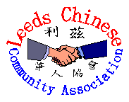

利 茲 華 人 協 會

LEEDS CHINESE COMMUNITY ASSOCIATION Ltd.

年 度 報 告

ANNUAL REPORT

2007
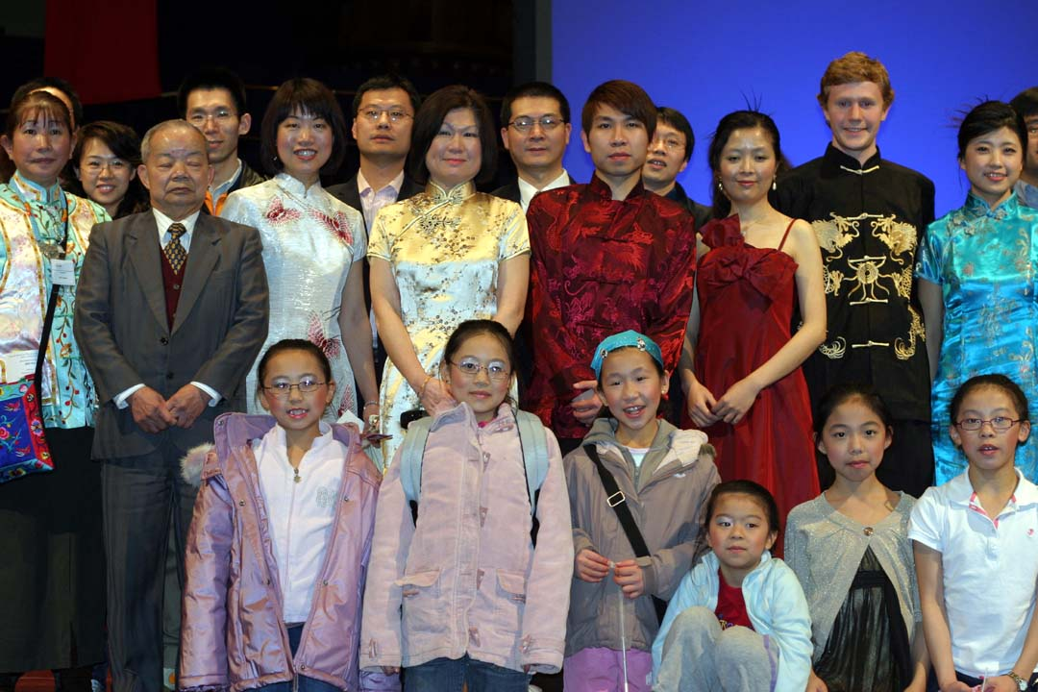

Leeds Chinese Community Association Ltd
84-86 North Street Leeds LS2 7PN Tel & Fax: 0113 2346019
Company No. 4429268 Charity Number 1095420
Email: lcca@lcca-uk.org Web: www.lcca-uk.org

目錄
CONTENTS

- 主席報告

CHAIRMAN’S REPORT

2 社團的目的和結構

OBJECTS AND STRUCTURE OF THE ORGANISATION

3 成就和演出

ACHIEVEMENTS & PERFORMANCE

4 未來的計劃

PLANS FOR THE FUTURE

5 年結

ANNUAL ACCOUNTS

6 委員會的董事和義務工作人員

BOARD OF DIRECTORS & VOLUNTEERS

鳴謝
ACKNOWLEDGEMENTS
主席報告

利茲華人協會差不多用了兩年時間去重組﹐集中所有相似的目標的華人慈善團體成為協會成員之一。雖然協會沒有得到利茲市政府的經費和幫助和受薪員工﹐ 本會亦能夠靠義工作者繼續提供服務。

在2007協會很成功在利茲美心大酒樓舉辦新春慈善午餐﹐和提供夏日教育性活動給所有協會成員。協會亦租出場地給婦女會管理的老人午餐會用膳。協會亦都是利茲華人中文學校和鈺鳴軒曲藝社的聚會的地方。音樂家和跳舞家都在協會練習唱歌﹐樂器和舞步。因為是很重要的協會能夠繼續提供場地去弘續和擴展我們的文化﹐傳統的習俗﹐所以是我們所有人值得驕傲的。

我代表協會委員會﹐藉此機會感謝所有義務工作者﹐贊助商﹐商業和個人將他們寶貴的時間和金錢奉獻給和支持協會。

利茲華人協會期待日後與各位能夠攜手合作建設未來。

CHAIRMAN’S REPORT

It’s now almost two years since the radical restructure of LCCA as an umbrella organization which admits Chinese charitable organizations in Leeds with similar aims and objectives. Despite the fact that there is no direct funding and support from Leeds City Council and no paid workers, LCCA continues to deliver services to the community by all our volunteers.

In 2007, LCCA successfully organised a Charity Luncheon at Maxi’s Restaurant to celebrate the Chinese New Year and provided summer educational activities and outings for all its member organizations. It also continues to facilitate the elderly Chinese Luncheon Club which is run by the Leeds Chinese Women’s Group in the Leeds Chinese Community Centre (LCCAC). The LCCA Centre remains the focal point and an alternate base for the Leeds Chinese Community School and the Yuk Ming Chinese Operatic Art Centre. Musicians and dancers come here to practise singing, dancing and playing Chinese instruments. It is so important that we can continue to provide the community a base in which they can learn and develop our much valued arts, culture and tradition, which we are all very proud of.

Therefore on behalf of the LCCA Board, I would like to take this opportunity to thank all the volunteers, sponsors, businesses and individuals who have donated generously their time and financial support to LCCA.
LCCA is looking forward to working with all of you in the community for many years to come.

協會的目的和結構

我們的慈善目標是去幫助利茲和鄰區的華人居民

減輕貧困
改善教育
提供福利資訊和幫助有需要的人
維持和管理華人社團的日後事務和目的

協會的結構

現在協會由六個慈善團體形成的﹐每個團體不可以有超過兩個代表去參加委員會做董事。 每個月就聚會一次﹐很多時義務工作者和董事們會為協會做到筋疲力盡去完成任務。協會很多時要依賴義務工作者﹐去提倡華人文化和教育性質活動例如新年活動。

OBJECTS AND STRUCTURE OF THE ORGANISATION

To promote the following charitable purposes for principally the Chinese residents of Leeds & its surrounding areas without prejudice-

Relief of poverty

Advancement of education

Provision of facilities in the interest of social welfare, recreation & for those who are in need

Maintain & manage the Chinese Community Centre in furtherance of these objects

Structure of the Organisation:

There are now six Member Organisations in LCCA. Each Member Organisation shall have no more than 2 Representatives who will be Trustees/ Directors on LCCA Board. They meet monthly to decide and manage affairs of the Association and they all work tirelessly towards the objects of the Association voluntarily. LCCA also relies on volunteers to promote and stage cultural / educational activities in the LCCA Centre as well as city wide, such as the Chinese New Year Celebrations.

MEMBER ORGANISATIONS


Leeds Wah Kwong Chinese Association
Room 1- 3, 1st Floor , 10 Merrion Street Leeds LS1 6PQ
Tel: 01132430832


利茲華人婦女組 Leeds Chinese Women’s Group
Room 4 – 7, 1st Floor, 10 Merrion Street, Leeds LS1 6PQ
Tel: 0113 2349030

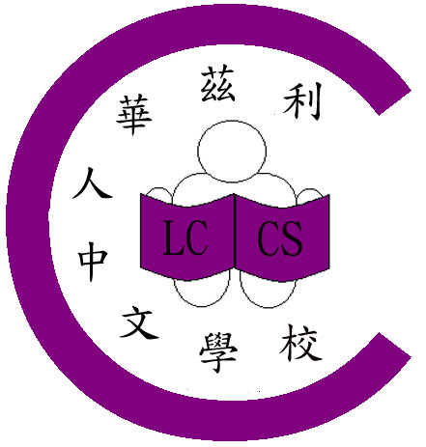
利 茲 華 人 中 文 學 校 Leeds Chinese Community School
Address: c/o Allerton C of E Primary School, Lingfield Approach, LS17 7HL



Address: c/o Little London Primary School, Meanwood Road, Leeds

利兹中国学生学者联谊会
Leeds Chinese Students & Scholars Association
www.leeds-cssa.org leedscssa@gmail.com



利兹鈺鳴軒曲藝
Leeds Yuk Ming Chinese Operatic Art Centre
E Mail: ymcoac@hotmail.co.uk

LCCA Ltd. is managed entirely by volunteers with the help of occasional session / project workers when funding is available.
成就和演出
- 利茲華人協會已改革成功所有華人慈善社團亦都有相似的目標。
- 協會在2007年二月在美心大酒樓舉辦的慈善新年聚餐和表演﹐是相當成功﹐娛樂性和食物都很豐富。
- 夏日旅行﹕由Local Network Fund 贊助協會舉辦了Blackpool, Lotherton Hall, Southport一日遊。這些旅行制做了社團團結的精神﹐亦改善後輩和晚輩相處的時刻。
- 協會繼續租了二日給利茲華人婦女會的老人午餐會作為午餐和聚會的地方。
- 逢星期一協會租給鈺鳴軒曲藝社作為練習的地方。
- 協會每二個星期日租給越南會作午餐會。
- 所收到的善款作為網址的支出。
- 協會申請的基金用來寫商業計劃書已完成。
- 申請利茲藝術基金去租利茲城市大會堂給2008年新年活動亦成功申請到。
- 協會和西約克郡警察部已取得聯繫﹐他們亦都想和華人社團合作去理解華人所需求。
- 成功得到利茲博物館和藝術館的支持﹐合作推廣約克郡中國節項目。

ACHIEVEMENTS & PERFORMANCE

- The restructure of LCCA is now complete which enables the Association to admit Chinese community organisations with similar charitable objectives

2. Chinese New Year Charity Luncheon and Performance Day in February 07 at Maxi’s Restaurant was a welcoming success for the Chinese community in Leeds. It was well attended with colourful entertainments and delicious food.

3. Summer trips to Blackpool, Lotherton Hall and Southport for children, elders & their families were sponsored with funding from Local Network Fund. These trips provided educational opportunities as well as promoting community spirit, and improved understanding between the older and the younger generations.

4 Hire of LCCA Centre by Leeds Chinese Women’s Group for Luncheon clubs 2 afternoons per week for the elders continues.

5. Hire of LCCA Centre by Yuk Ming Chinese Operatic Arts Centre for performances & practices Monday evenings

- Hire of LCCA Centre by Vietnamese Group for Sunday Luncheon club

7. Donation received to establish LCCA web-site which is now live

8. Grant applied to write LCCA Business Plan which was successfully completed

- Grant applied from Arts@Leeds to hire Leeds Town Hall for Chinese New Year 08 Celebrations which was successful

- LCCA has also established links with West Yorkshire Police Community Dept. to promote understanding and working between the Chinese communities & WYPD

- Successful in supporting funding application to work in partnership with Leeds Museums & Galleries to promote Chinese culture in the China in Yorkshire Project.
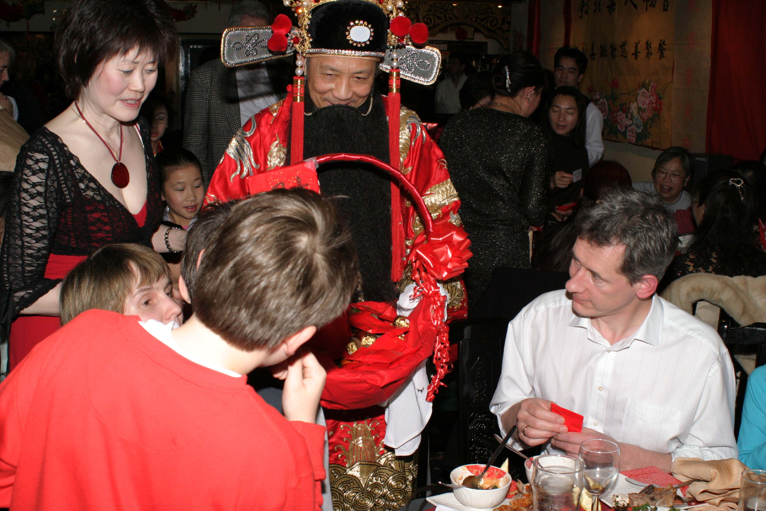
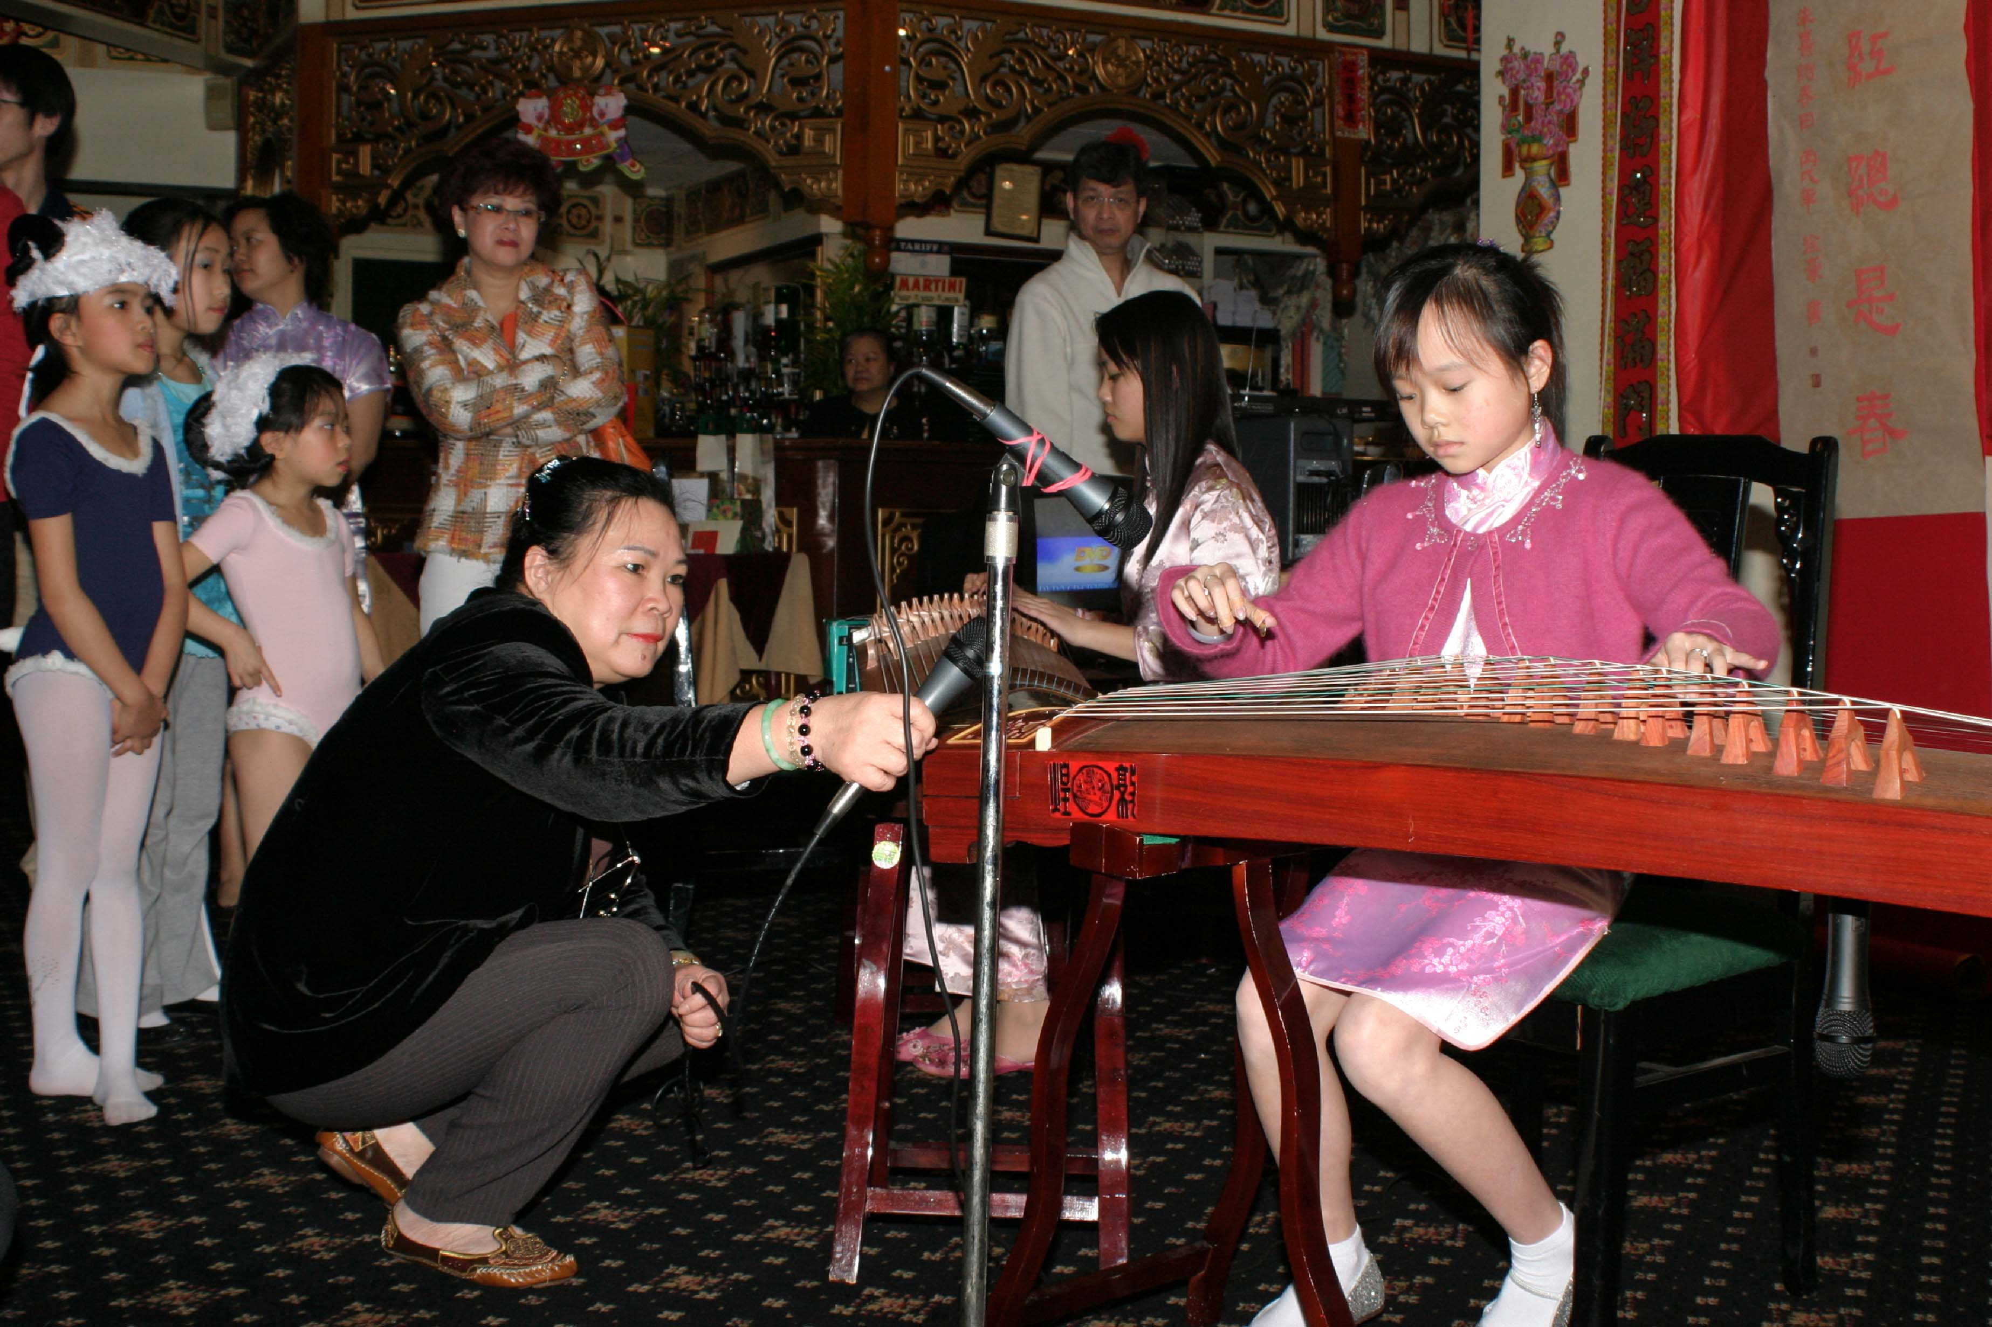
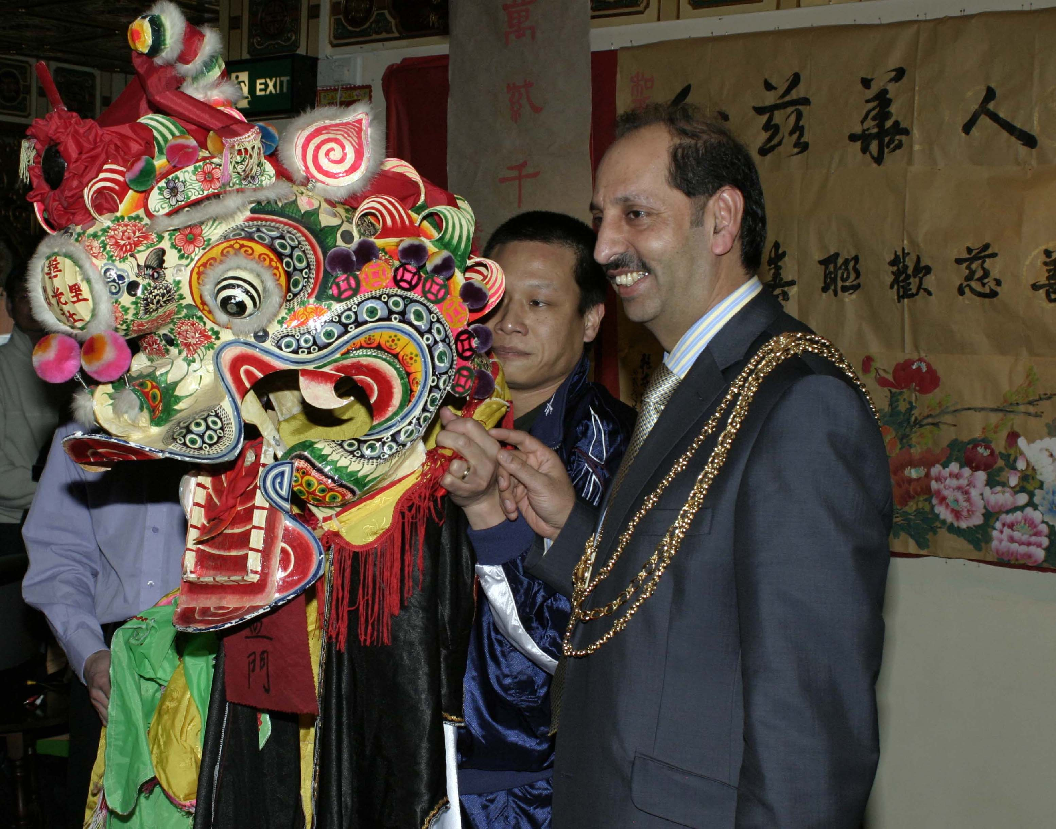
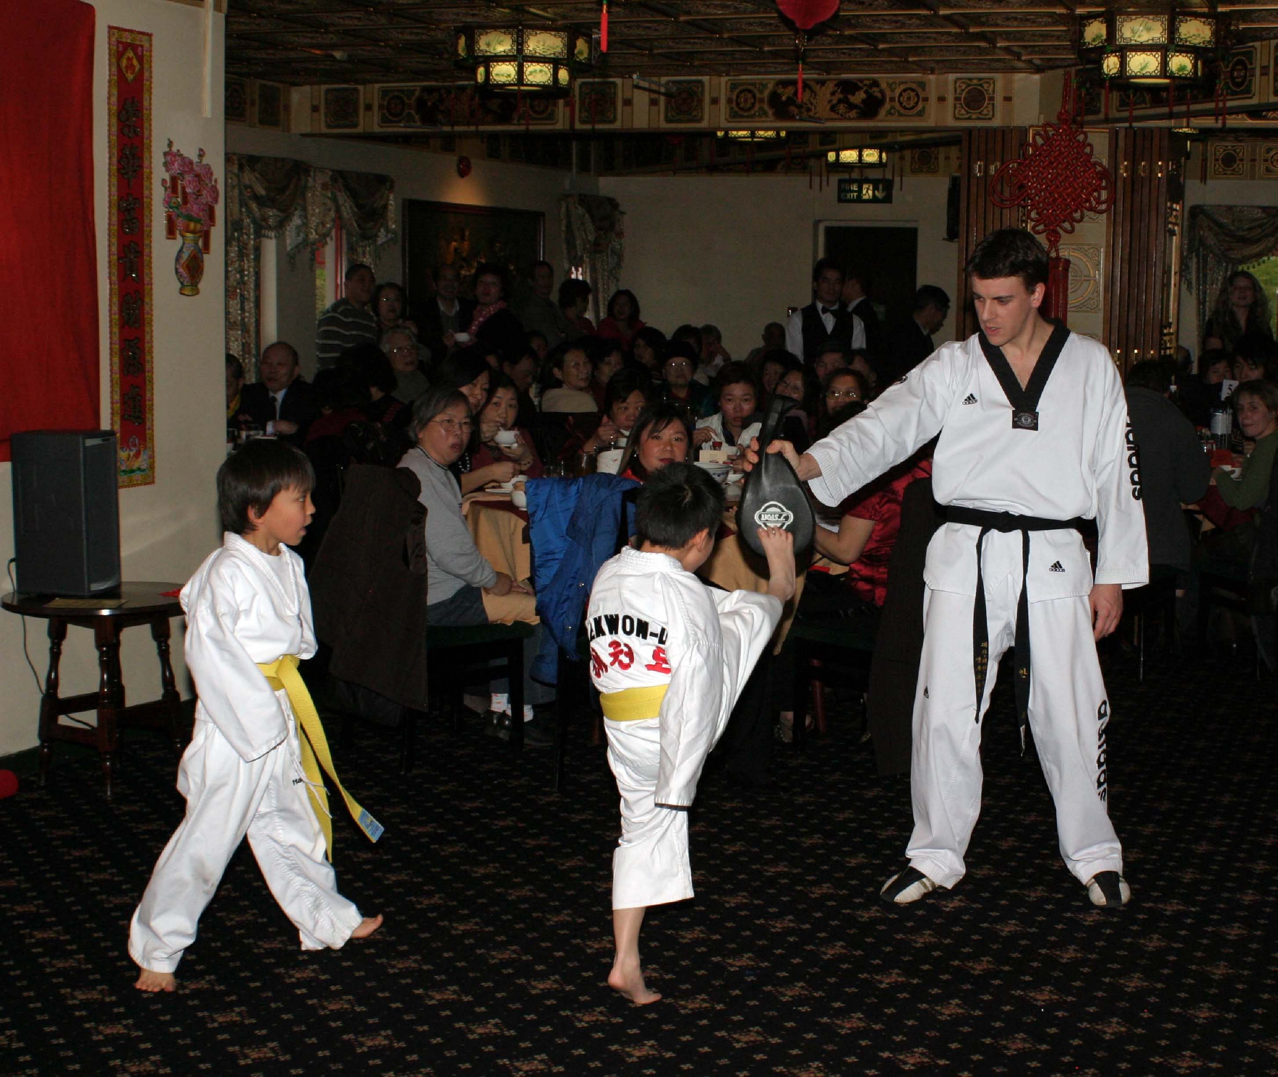
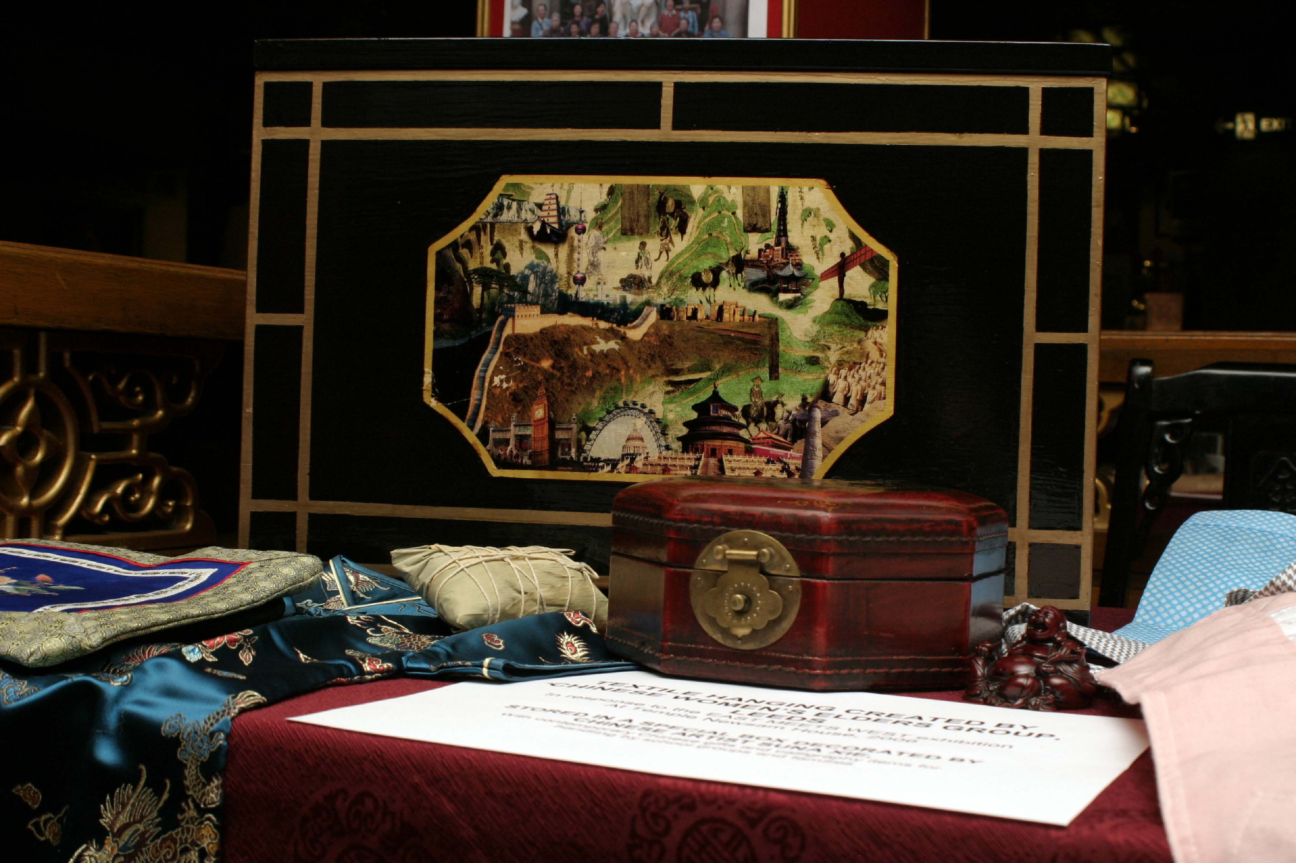

未來的計劃

利茲華人協會會盡量去申請基金來改善和增加協會的活動。這是相當重要的如有經費協會就能夠開門。另一個計劃是要按裝一部升降機可以給老人或傷殘人士上落。另一個基金是要申請一個全職的經理來管理協會。

其他計劃如下﹕

2008年二月在利茲市中心舉辦中國新年。

2008年六月慶祝龍舟節

與其他社團或對社區有興趣的商業公司合作

與英國國家醫療基金會合作﹐對華人社團的健康需求有聯繫。

增加會員和義工作者

增設個人會員組加入協會的委員會

PLANS FOR THE FUTURE

LCCA is trying to secure further funding to improve the LCCA Centre to provide an extensive programme of activities. This is vital in ensuring the financial viability & substantiality of LCCA Ltd. One of the major projects planned is to install a passenger’s lift at LCCA Centre.
Funding is also being sought to employ a full-time LCCA Centre Coordinator to oversee & to manage LCCA and its Centre activities.

Other plans are-

Chinese New Year Celebrations in Leeds City Centre in February 08

Dragon Boat Festival Celebrations in June

Working in partnership with other community organisations, statutory bodies & Community Interest Companies for income generation and to further the objects of the Association

Establish links with Leeds Hospitals (NHS) Trust to benefit the Chinese communities in health needs.

Increase membership & voluntary base

Establish policy in admitting individuals into Individual Members Group
ANNUAL ACCOUNTS

BOARD OF DIRECTORS
利兹华人协会的董事和執委和義務工作者

Mr. Alex T.W. Kong CHAIRMAN

Mrs. Judy Pease VICE - CHAIRMAN

Mr. David Cheung VICE – CHAIRMAN

Mrs. Sally M.H. Pegg SECRETARY

Dr. Yi Li SECRETARY

Mr. Park Chua TREASURER

Mr. Xin Jiang DIRECTOR

Mr. Peter K.C.Pang DIRECTOR

Dr. David Wei Ji DIRECTOR

LCCA Volunteers

Mr. T.L.Yung Mrs. Candy Lam
Mr. K.F.Chan Mrs. Tatum Yip
Mr. Chaoyang Ma Mrs. Betty Chui
Mr. Hong Yue Mrs. Mo Ching Chan
MR. Jimmy Choo Mrs. P.W.Kwan
Mr. Jimmy Chan

致谢

利茲華人協會委員會和董事們很多謝所有的基金會﹐贊助商﹐公司﹐超級市場﹐商人或個性人仕慷慨地付出時間和金錢來支持本會的慈善棕旨和目的。

ACKNOWLEDGEMENTS

LCCA Board of Directors would like to thank all the funding organisations, sponsors, companies, supermarkets, businessmen & individuals who have donated their time, resources and offered financial support and funding to further the aims and objectives of the Charity.

